**Step by Step guide on How to install Docker on Windows 10/11**

look at installing Docker on Windows 10 or Windows 11.

**Requirements**

1. Windows 10 with 64 bit
2. Windows 11 with 64 bit operating system
3. 2004 or higher version of Pro
4. 1909 version or higher for Enterprise or Education Version

**Specifications**

1. While choosing for windows 10 or 11 with 64 bit, it must be having higher level of translation
2. 4GB RAM or Higher version but not less
3. BIOS settings should have hardware virtualization support enabled.
4. Hyper V feature, WSL 2 feature and Container feature should be enabled in windows.
5. Windows supported by Microsoft need to be updated, if computers have older versions of windows.

**Step 1: Downloading Docker**

The first place to start is the [official Docker website](https://www.docker.com/get-started/) from where we can download Docker Desktop.

Please note that Docker Desktop is intended only for Windows 10/11 and not for Windows Server.



So let’s open the downloaded installer and begin the installation.

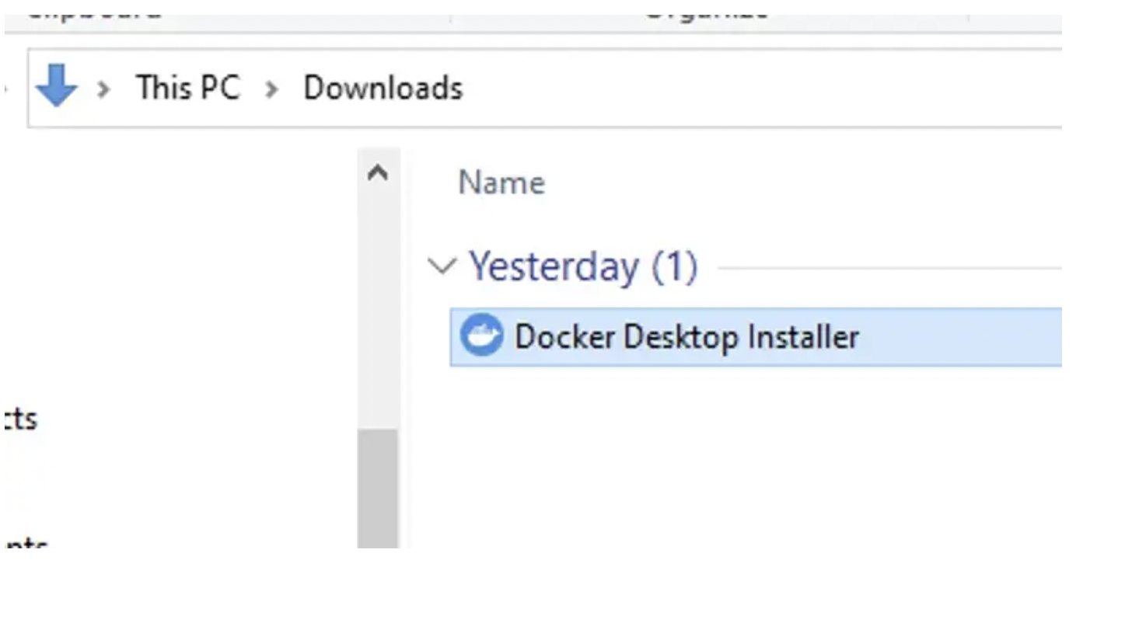

**Step 2: Configuration**

To run Linux on Windows, Docker requires a virtualization engine. Docker recommends using WSL 2

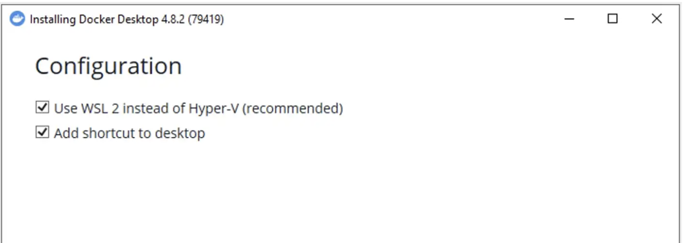

**Step 3: Running the instalation**

Click Ok, and wait a bit…

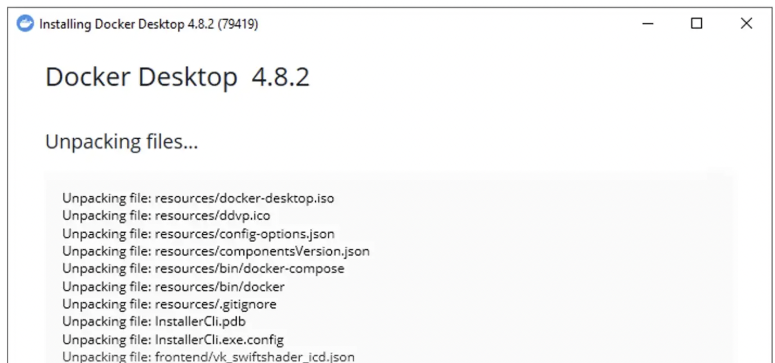

**Step 4: Restart**

For Docker to be able to properly register with Windows, a restart is required at this point.

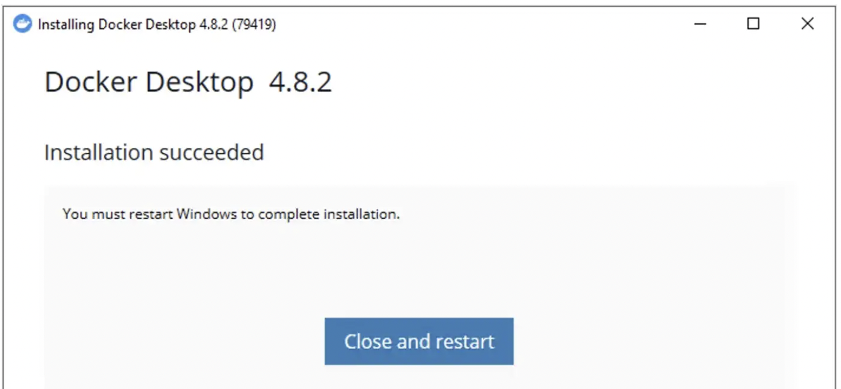

**Step 5: License agreement**

After the restart, Docker will start automatically and you should see the window below:

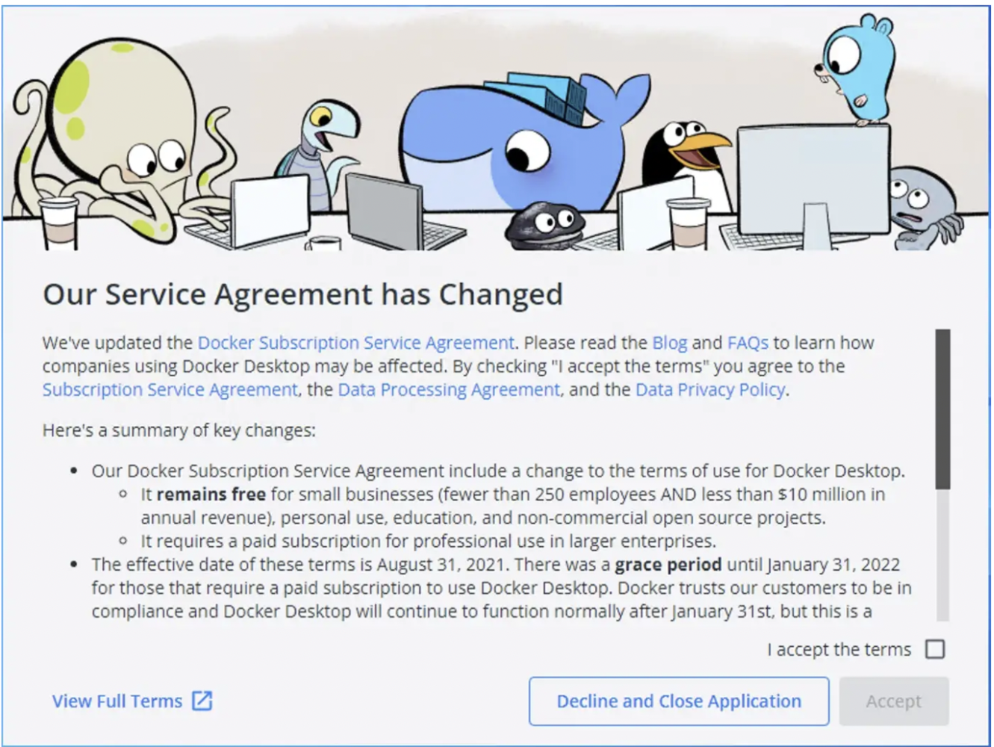

Essentially, if you are a small business or use Docker for personal use, Docker contains to remain free. However, **if you are in a large organization, please get in touch with your IT department to clarify the license agreement.**

**Step 6: WSL 2 installation**

After you accept the license terms, the Docker Desktop window will open. However, we are not done yet. Since we have selected WSL 2 as our virtualization engine, we also need to install it. **Don’t click Restart just yet!**

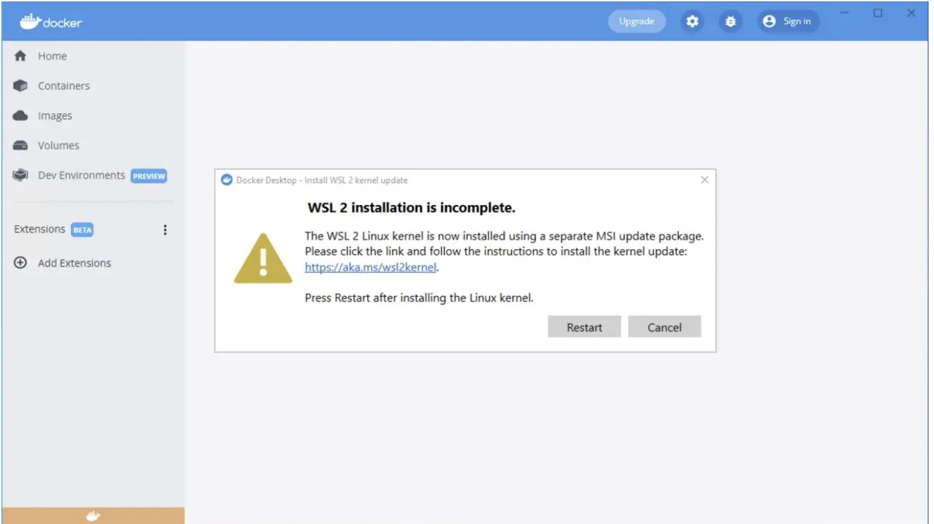

Follow the link in the dialog window and download WSL 2.

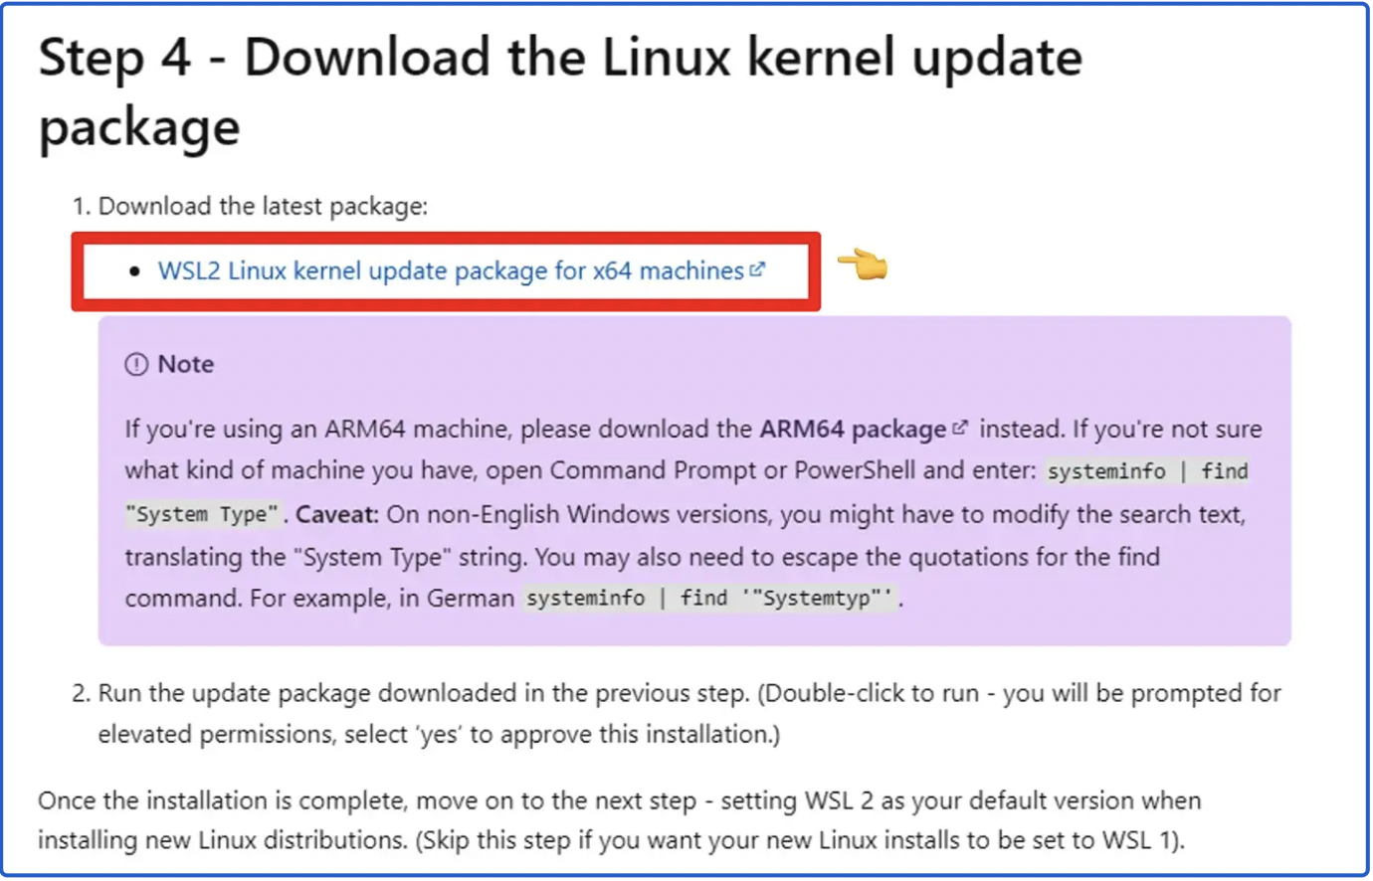

Open the installer.

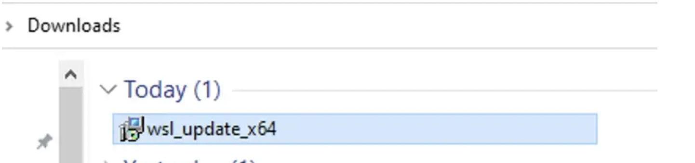

Click on *Next* to begin installing the Windows Subsystem for Linux (WSL).

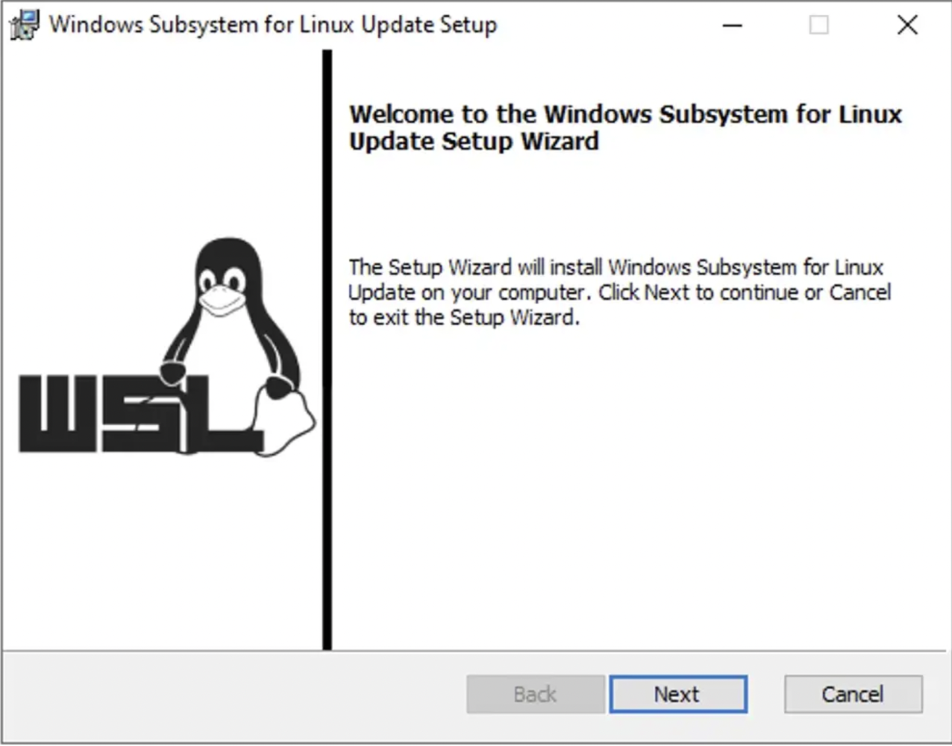

After a few seconds, the installation should complete. So you may click on Finish.

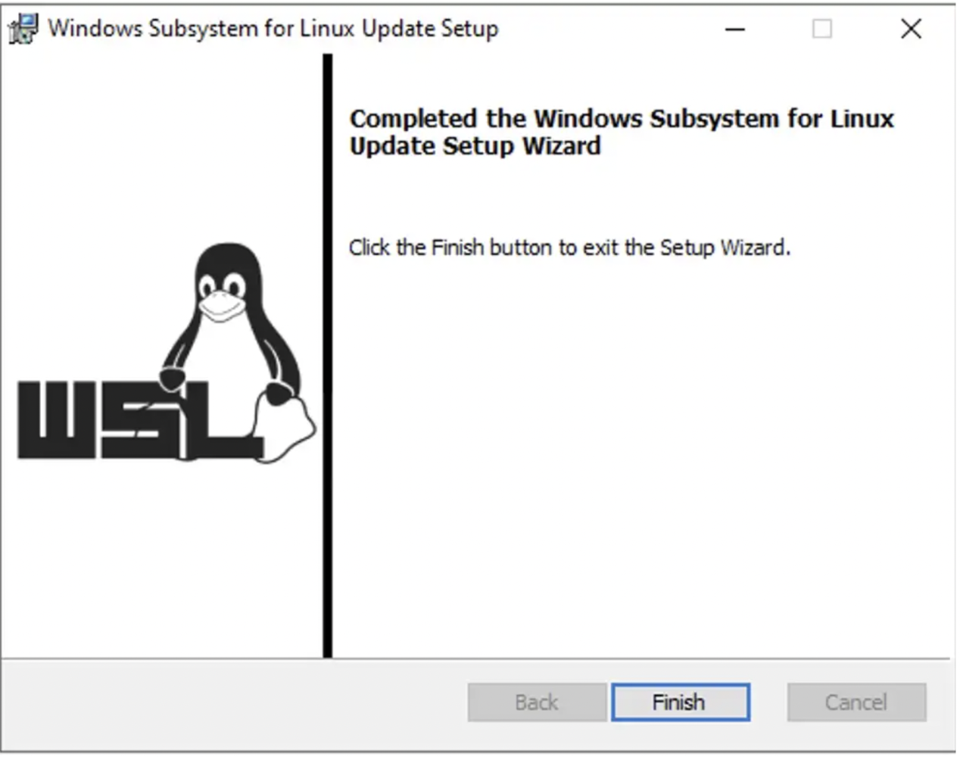

If you still have the Docker Desktop dialog window in the background, click on Restart. Otherwise, just restart your computer as you normally do.

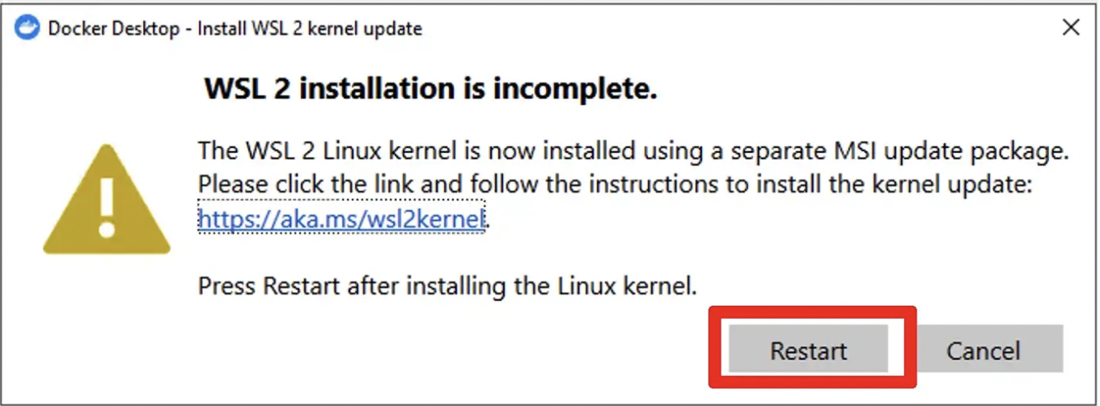

**Step 7 — Starting Docker Desktop**

If Docker Desktop did not start on its own, simply open it from the shortcut on your Desktop.

If you wish, you can do the initial orientation by clicking Start.

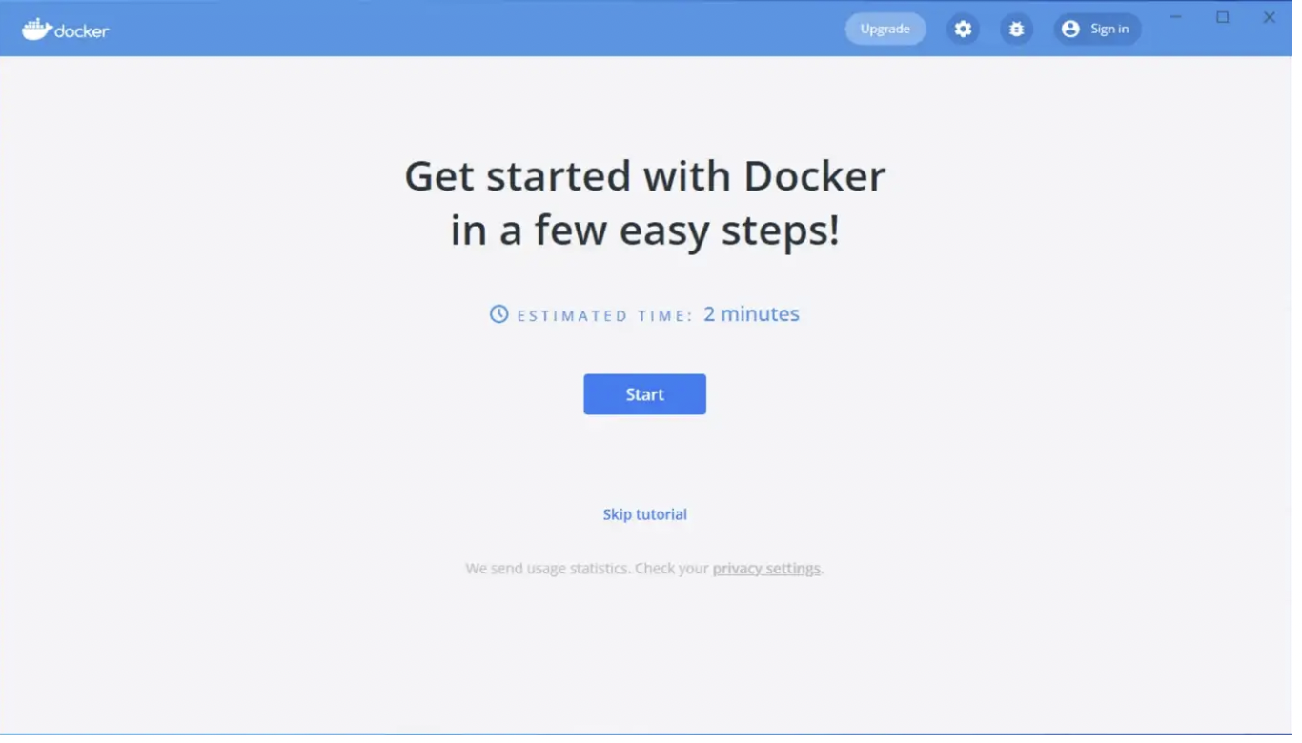

After this, your Docker Desktop screen should look like this.

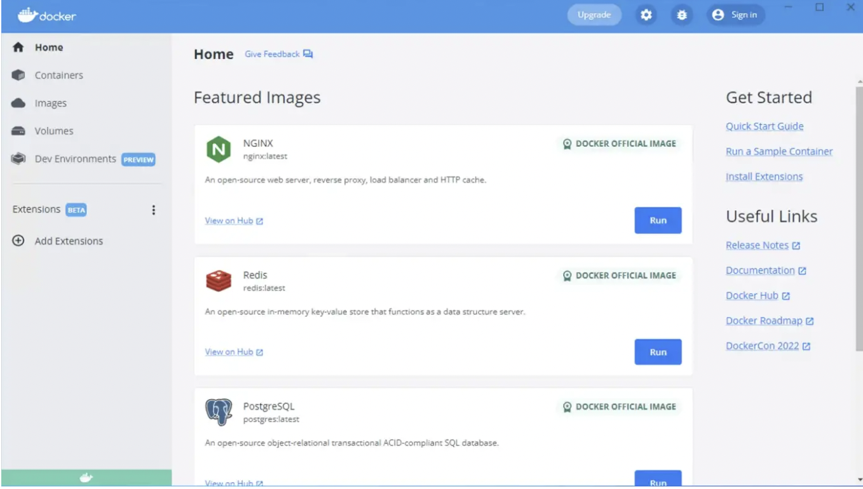

**Step 8— Testing Docker**

Open your favorite command line tool and type in the following command:

docker run hello-world

This will download the hello-world Docker image and run it. This is just a quick test to ensure everything is working fine.

**Step 9 — Automatically start Docker [Optional]**

**This step is dependently optional**, but if you are working a lot with Docker, you may want to configure Docker Desktop to start automatically once you start Windows.

You can enable this from settings, as shown in the screenshot below.

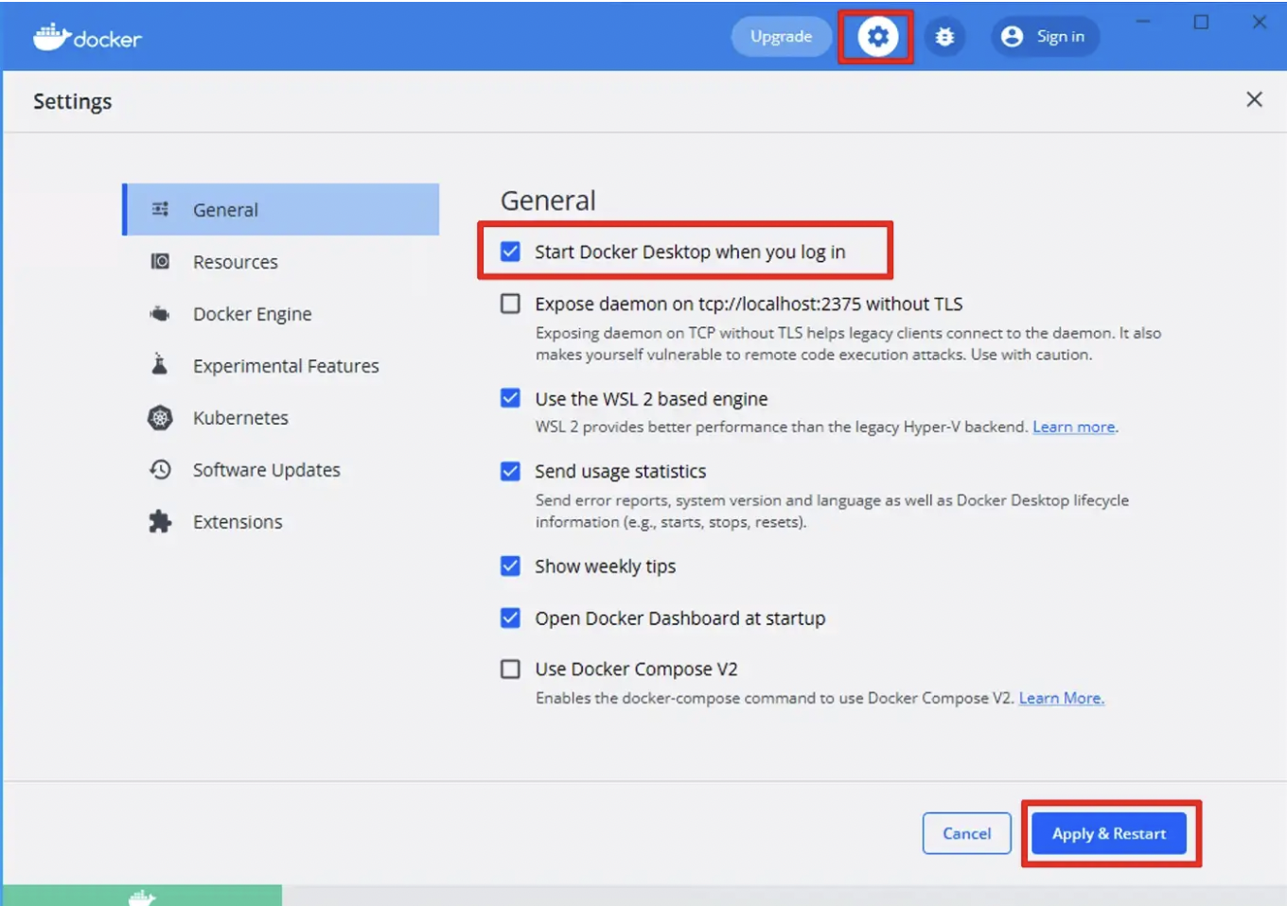

Sometimes we do get issues with such setups and as per best of memory below steps should be able to help in troubleshooting the issues. Let's look at it...

**Troubleshooting — Issues installing WSL 2**

When opening Docker Desktop for the first time, possible error:

*Failed to deploy distro docker-desktop to C:\Users\shashank\AppData\Local\Docker\wsl\distro: : Please enable the Virtual Machine Platform Windows feature and ensure virtualization is enabled in the BIOS.*

*For information please visit* [*https://aka.ms/wsl2-install*](https://aka.ms/wsl2-install)

*Some WSL system related access rights are not set correctly. This sometimes happens after waking the computer or not being connected to your domain/active directory. Please try to reboot the computer. If not sufficient, WSL may need to be reinstalled fully. As a last resort, try to uninstall/reinstall Docker Desktop.*

**Option : Enable Virtual Machine Platform**

Make sure that Virtual Machine Platform is enabled on your Windows installation. You can easily check this by opening the *Turn Windows features on or off* from your Control panel.

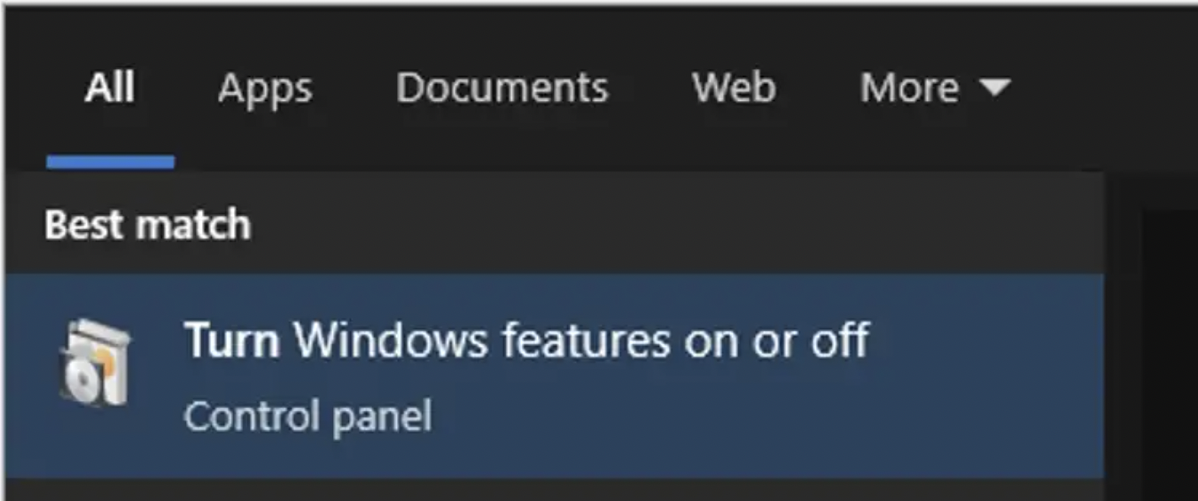

On your list of features, check that Virtual Machine Platform is enabled.

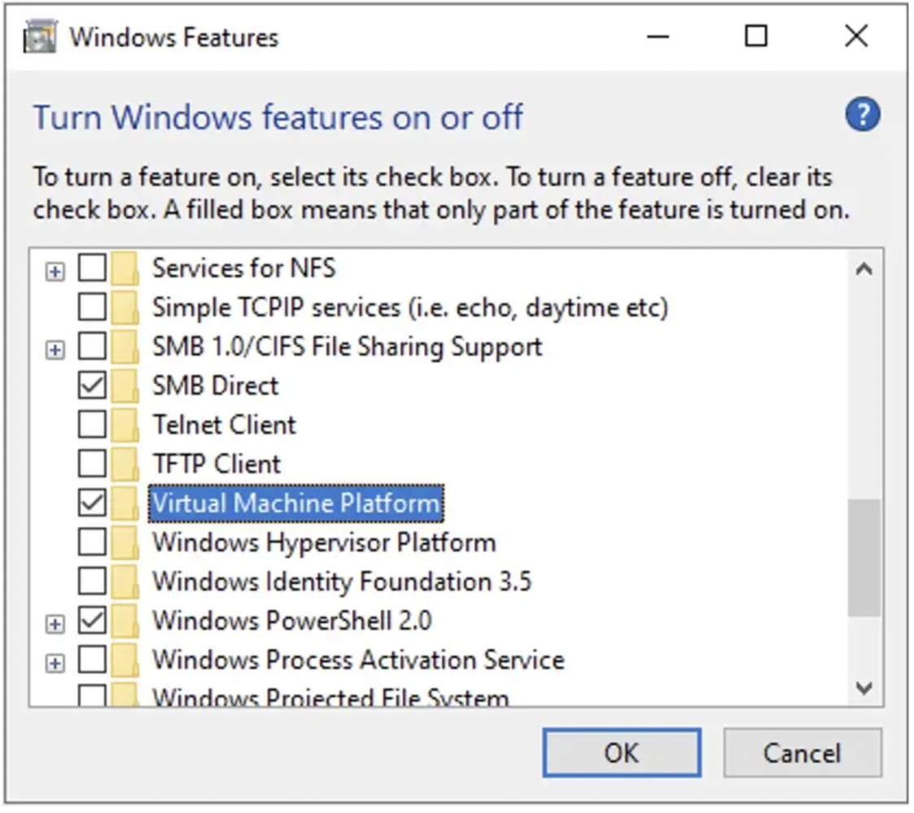

**Useful Links for Documentation**

https://docs.docker.com/desktop/install/windows-install/